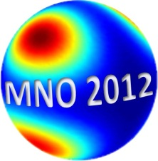
1st INTERNATIONAL WORKSHOP ON
METALLIC NANO-OBJECTS: FROM FUNDAMENTALS TO APPLICATIONS
elaboration, characterization, properties and applications
15th-16th November 2012, Saint-Etienne, France
Website: https://dossier.univ-st-etienne.fr/destoucn/www/MNO2012
Or from June 12: http://mno2012.univ-st-etienne.fr
This workshop aims to provide an overview on recent advances and challenges in the development of nano-objects and their applications in materials science. Academic and industrial scientists, technologists and students from various national and international universities, institutes or companies are expected to participate in the workshop. This workshop will include a number of talks by key experts and well known speakers on the elaboration, assembly, manipulation, modeling and characterization of metallic nano-objects as well as on their applications. We solicit abstract for oral or poster presentations in the following topics.
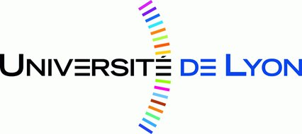
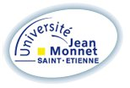
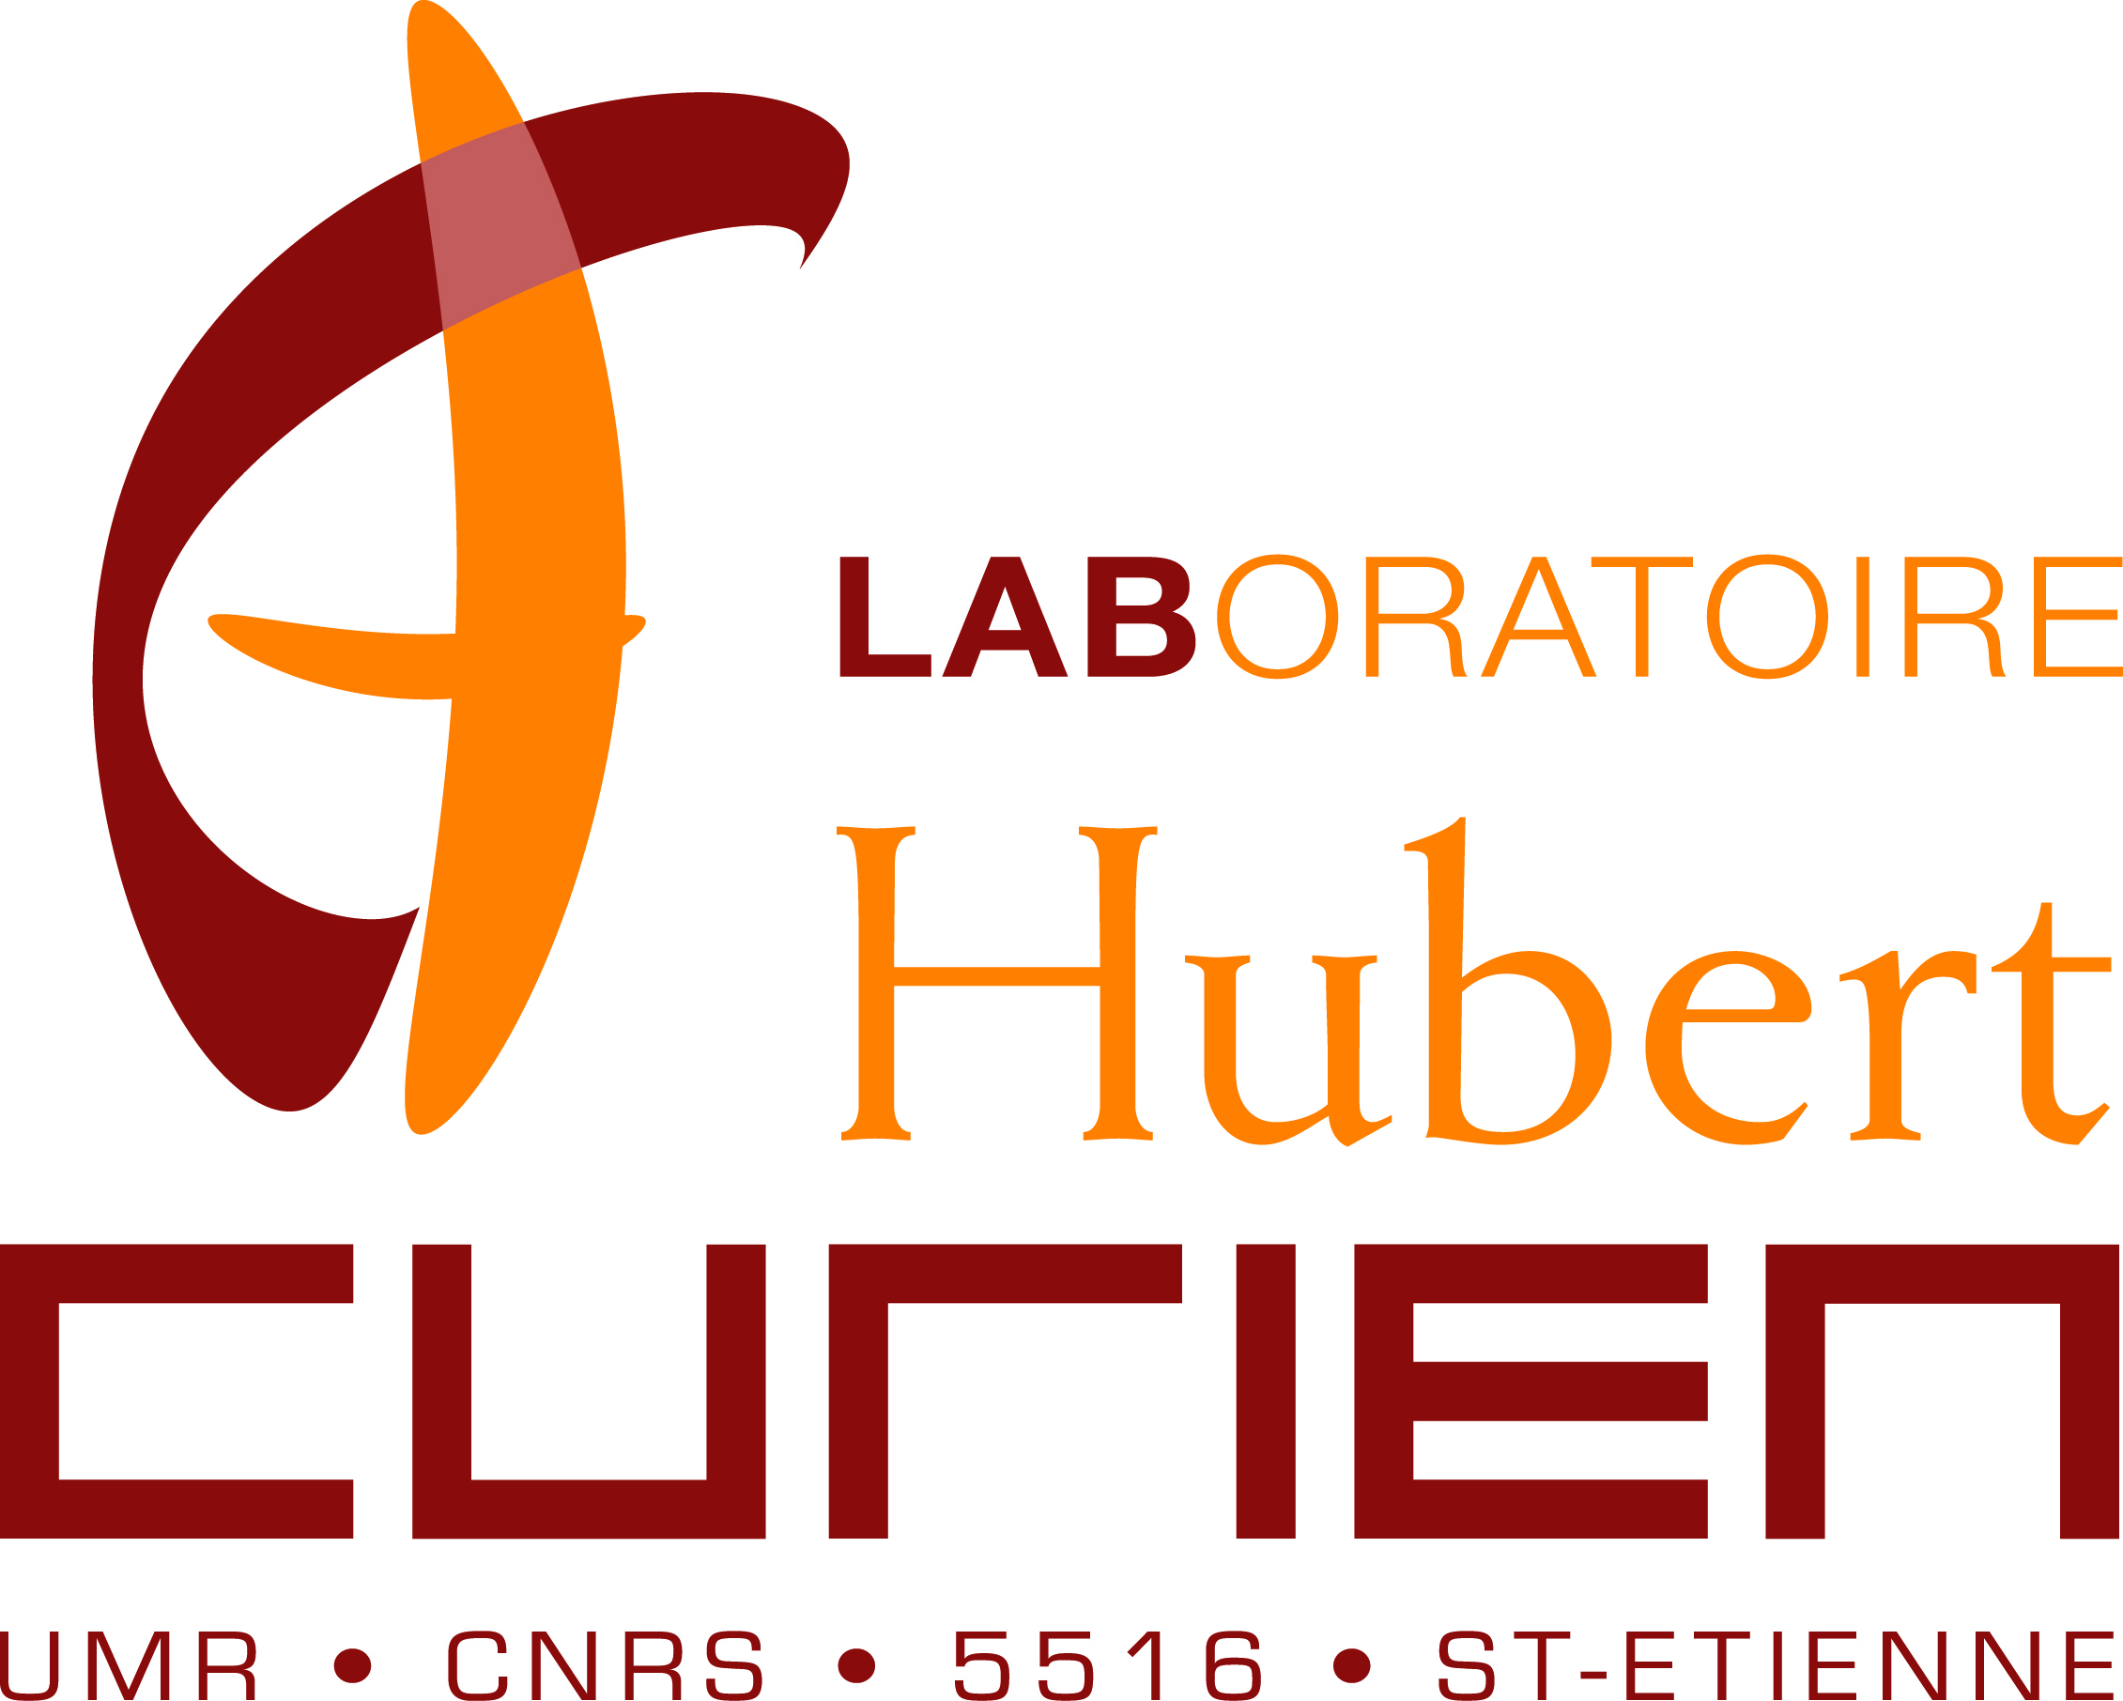
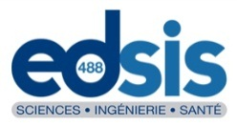
Invited speakers
- Philippe Colomban LADIR-UPMC, Paris, France
- Javier García de Abajo IQFR-CSIC, Madrid, Spain
- Frank Hubenthal Institut für Physik and Center for Interdisciplinary Nanostructure Science and Technology - CINSaT, Universität Kassel, Germany
- Gerhard Seifert Martin-Luther-Universität Halle-Wittenberg Zentrum für Innovationskompetenz SiLi-nano& Fraunhofer-Center für Silizium-Photovoltaik CSP, Germany
- Tetsu Tatsuma University of Tokyo, Japan
- Gregory Wurtz Department of Physics, King's College London, United Kingdom

TOPICS
- Plasmonics and nanophotonics, non linear optics, nano-thermal effects
- Growth, reshaping and organization techniques of metallic nanoparticles and nanostructures
- Characterization and modeling of the optical properties, single metallic nano-objects, interparticle coupling
- Applications in art, catalysis, photovoltaic, nanolaser, data storage, cryptography, biology,…

Submission deadline:
July 5, 2012

